

My Medicine Manager

Seán McElroy

C16437464

Submitted in partial fulfilment of requirements for the degree of BSc in Business Computing.

Technological University Dublin

April 2020

Supervisor: Patrick Matthews

**Acknowledgements**

I would like to thank all the people who helped me reach this point in my project including the lecturers of this course who taught me many of the skills needed to do this project.

I would like to thank my supervisor Patrick Matthews who had weekly meetings with me and provided constructive input. I would also like to thank my second reader Don Ryan, who provided concise course of action during the checkpoints.

I would especially like to thank Fiona Hannigan from the Irish Pharmacy Union for providing me sample medicine item data, as well as description of each field.

I would also like to thank my family who have supported me throughout the duration of the project and the course. My father who helped me narrow my focus near the end, his input was crucial. Mostly I would like to thank my Aunt Sinéad, a pharmacist, who gave me advice, answered any questions I had and gave me a better insight into the business processes.

**Abstract**

Currently today most of us do not have easy access to our medicine history. If we do, more than likely it is on physical paper. Most other aspects of our lives are getting improved with technology. From food delivery, to online dating, yet the medical industry in Ireland is lacking in terms of technology integration.

The aim of the project was to develop a better and more transparent patient-pharmacy experience

The goals of the project were to:

1. connect patients with their pharmacies to enable a more convenient and helpful experience for both parties which would reduce waiting times and improve clarity.
2. notify patients when their prescriptions are ready for collection
3. give patients more insight into their own medical history
4. benefit pharmacies by knowing prescription details and being able to prepare them in advance.
5. keep patients informed on relevant issues. The Covid-19 pandemic arrived during my project so I added a module on that
6. online connection / clarity is of particular importance during the current global pandemic. Less waiting time in pharmacies also helps with social distancing. Many patients will have underlying conditions which makes this even more important

**Table of contents**

1 Introduction 6

1.1 Project Objectives 7

1.2 Business Case 9

1.3 Business Rules 10

1.4 Business Actors 13

1.5 Requirements 16

2 Design 19

2.1 System Architecture Abstract 19

2.2 System Architecture in Detail 20

2.3 Architecture Explained 21

2.4 Design 22

3 Data model 33

3.1 Entity Relationship Diagram 33

3.2 Entity Medicine Data 34

3.3 IPU product file headings 35

4 Implementation 36

4.1 APIs 36

4.2 Prescription 38

4.3 Patient 40

4.4 Patient Appointments 42

4.5 Medicine 43

4.6 Covid-19 45

5 Test Cases 47

6 GDPR 49

6.1 IPU Data protection GUIDE FOR Community Pharmacy 49

GDPR 50

6.2 Definitions 50

GDPR 51

6.3 Types of Data 51

6.4 Access to Personal Data by data Subject 51

6.5 Destruction of records 52

7 Conclusion 53

# Introduction

Being connected to someone that owns and operates a pharmacy, I had a better insight to some of the business processes and noticed there are many inefficiencies in the current system of prescription fulfilment. Queues within pharmacies can quickly become far too large.

As well, being a patient in the healthcare system as we all are, I realized that I have very few records of the medicines I have been prescribed as well as the number of different medical appointments I have had. Healthcare systems in countries like Sweden allow its citizens to easily access their medical data. Currently in Ireland the information is not so easily accessed.

I wanted to improve the process of prescription dispensing and increase medical information access through a web app for pharmacies and a mobile app for patients.

This set of connected applications were designed to improve clarity throughout prescription fulfilment process.

The main application feature is being able to share prescription information with the pharmacy before arriving at the premise and getting alerted when your prescription is ready, thus reducing time being wasted by the patient and allowing the pharmacy streamline the delivery of their service. This also helps with social distancing which has become important given Covid-19, particularly for people who have underlying conditions.

## Project Objectives

The main objective of project was to improve the patient experience in the prescription fulfilment process. The current process of receiving a prescription from a prescriber (usually a doctor), travelling to a pharmacy to submit it, waiting for it to be filled or in some cases having to return to the same pharmacy after stock has been ordered to fully dispense to prescription has a number of flaws. By using the main application feature of a person sharing their prescription information with the pharmacy electronically before arriving to the premises, the patient will save time, the pharmacy has the opportunity to manage their processes better.

The patient's experience is also improved as they have full access to their medical history, including previous doctor's appointments, prescription and medication history

The system should support the following:

Pharmacy

Register and login

View medicine stock/update stock

View medicine details.

View their patients

View their patient’s prescription records.

View the current prescription forwarded by the patient

Update current prescriptions

Show Daily Covid updates

Patient

Register and login

Send Prescription Image to selected pharmacy with an optonal message from the patient

Receive update on status of prescription (e.g. ready for collection).

View their prescriptions.

Show Daily Covid updates.

Administrator

Login

Update IPU (Irish Pharmacy Union) Product file. (Medicine)

System

Send text message to patient if prescription is ready or cancelled.

Refresh call to covid 19 csv api.

Generate jwt key for correct user.

## Business Case

During the current global pandemic pharmacies, while continuing to provide an essential service, must play their part in infection control. Pharmacy owners have a duty of care to both their staff and members of the public. Most pharmacy businesses are currently operating behind closed doors and limiting access to their shop floors. My Medicines Manager facilitates such social distancing by allowing the patient to order prescriptions by sending images to the pharmacy and has a feature which allows the pharmacy to alert them efficiently when items are ready for collection. This assists the pharmacy business with infection control as well as running the service in a timely manner.

Generally, My Medicines Manager will reduce wait times for patients, thus improving patient satisfaction and potentially promoting patient loyalty. Given that most pharmacies operate just-in-time stock control, it also has the potential to reduce stock levels on dispensary shelves and therefore improving cashflow.

Pharmacies are required to keep a record of all prescriptions dispensed. My Medicines Manager allows storage of prescriptions with images of the prescription. Storing the image will allow ease of access should there be future queries on the transaction, thus saving staff time.

Pharmacies will be able to view patients' prescriptions which have been dispensed in other pharmacies. Currently there is no one single place where all of this information is stored and can be accessed by healthcare professionals. This is an important patient safety feature reducing the risk of an adverse drug interaction, duplicating medications or to minimise the misuse of drugs. The pharmacist may also be able to use this information to improve patient adherence to medication regimes. It may also help reduce misuse of drugs

Patients can have access to an app on their phone. That improves the process for them and also maintains records of their prescriptions, medicines and doctors’ appointments.

## Business Rules

* Users must be logged in to access features.
* Pharmacy can update their prescriptions including status but not other pharmacies’ prescriptions.
* When sending a prescription to a pharmacy the patient gives permission to that pharmacy to access to their prescriptions with other pharmacies
* Patients can view their prescriptions
* Admin only can update the product file

My Medicine Manager Web App Image

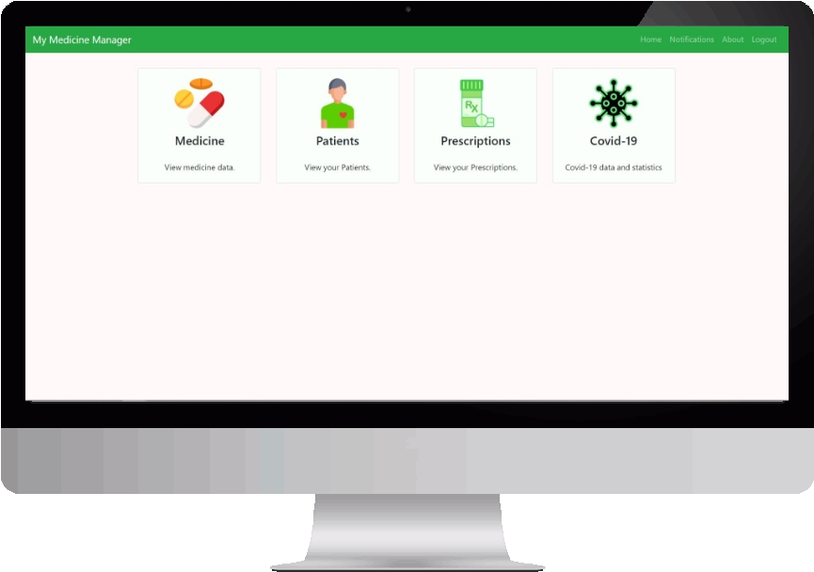

Patient Pal mobile App Image

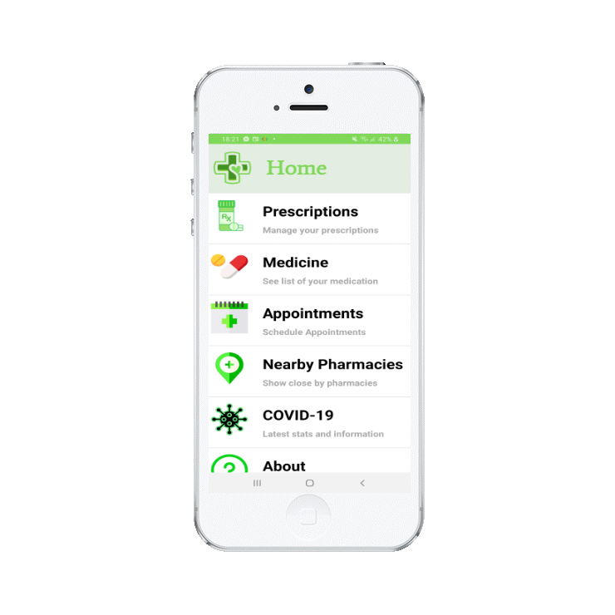

## Business Actors

**Pharmacy**

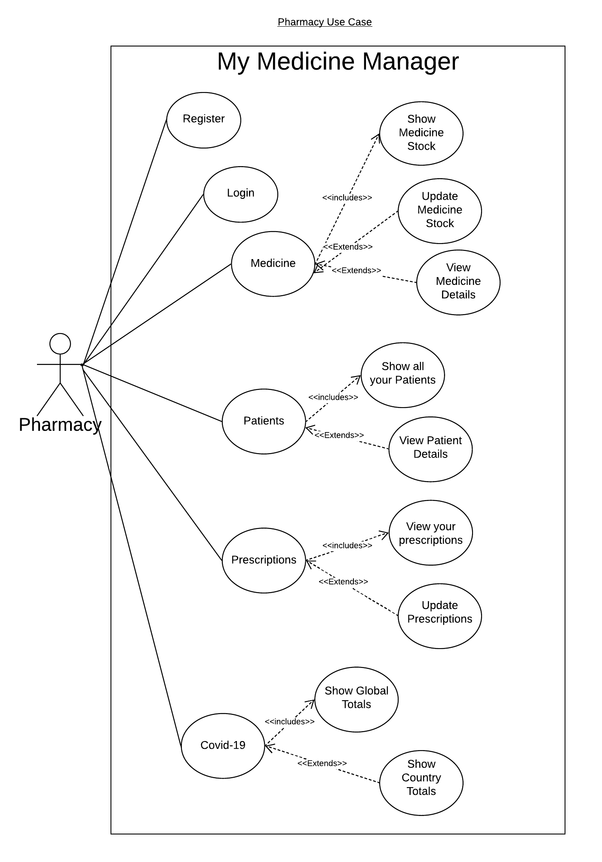

**Patient**

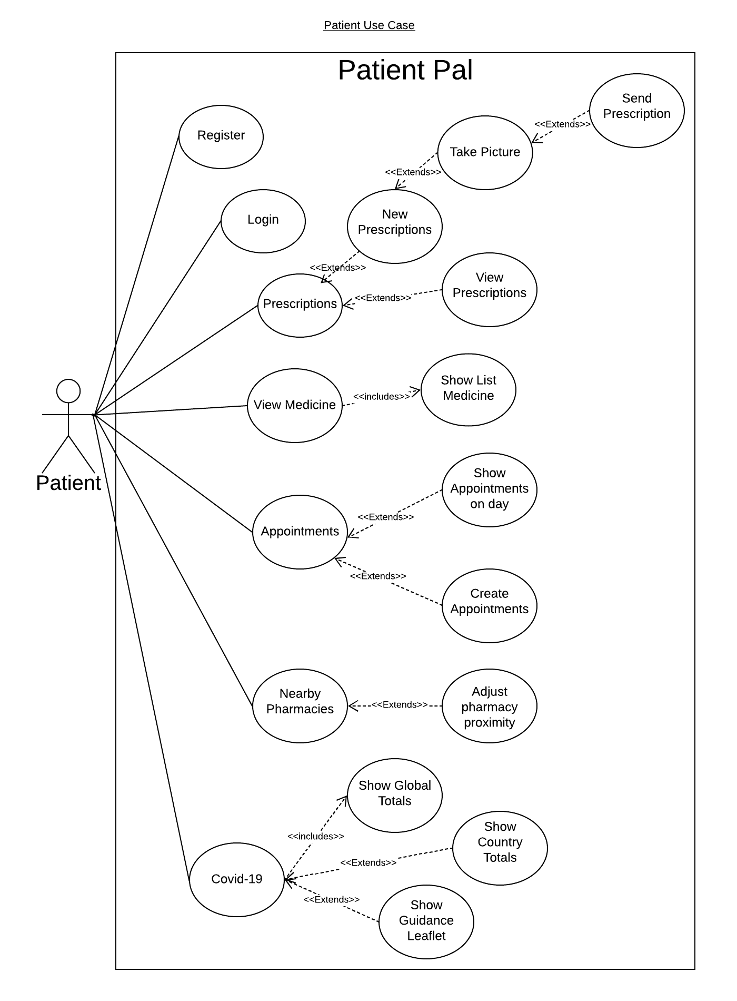

**Admin**

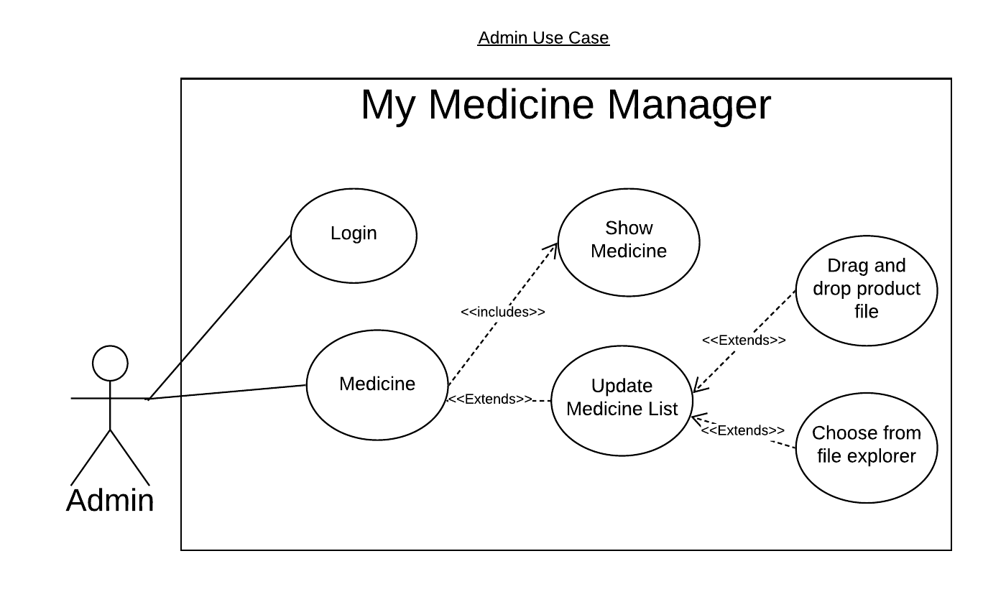

## Requirements

**Pharmacy**

|  |  |  |
| --- | --- | --- |
| Function | Requirement | Justification |
| Register | New pharmacy users can be created with pharmacy details | User needs to be logged in to use application. |
| Log in/Log out | Existing pharmacy users can log in log out | User needs to be logged in to use application. |
| Update Medicine Stock | Ability to adjust stock of medicine items | If pharmacy stock changes. User should be able to adjust the stock. |
| View Medicine Item Details | Pharmacies can view more details of medicine | Pharmacy wants to see more details about medicine item. |
| View All Patients | Pharmacies can view a list of their patients. | Pharmacy wants to see their patients |
| Search For Patient | Pharmacies can Search patient list by patient last name | Pharmacy may look for a specific patient. |
| View Patient Precriptions | Pharmacies can view all their patients’ prescriptions | For better decision making. Safety of patient avoid drug misuse |
| View Pharmacy Prescriptions | View all prescriptions that have been sent to pharmacy | Users should see the prescriptions that they have. |
| View Prescription | Pharmacies can view prescription details | Pharmacies should be able to see full details of a prescription |
| Update Prescription | Pharmacies can update their prescription records. Status, add line items | Pharmacies need to be able to update prescriptions for record keeping. |
| View Covid-19 Data | Pharmacies can view daily stats for covid-19 | Pharmacies need to be aware of covid-19 figures for the safety of their staff and their patients. |

**Patient**

|  |  |  |
| --- | --- | --- |
| Function | Requirement | Justification |
| Register | New patient users can be created with patient details | User needs to be logged in to use application. |
| Log in/Log out | Existing patient user can log in or log out | User needs to be logged in to use application. |
| Create Prescription | Patient can create new prescription request with selected pharmacy and an image of prescription | Patient gives permission to pharmacy to access their data. Patient does not need to wait long time in pharmacy |
| View Current Prescriptions | Patient can view history of prescriptions | Patient will have access to more medical information about themselves |
| Appointments | Patients can view appointments on a given day | Patient will have access to history of their appointments and dates along with them. |
| Create Appointment | Patient can create Appointments in the calendar | Patients will have saved appointment details for future appointments |
| Nearby Pharmacy | Patient can view Nearby pharmacies. | Shows pharmacies in covid-19 2k radius. |
| Adjust Pharmacy radius | Patient can adjust the radius of pharmacies nearby | Show a patient, nearby pharmacy that they can go to. |
| Covid-19 Information | Patients will have access to covid-19 data as well as guideline information. | Patients, generally are people that have compromised immune systems. By having easy access to covid data as well as guidelines. They can avoid contracting the virus or spreading it. |

**Admin**

|  |  |  |
| --- | --- | --- |
| Function | Requirement | Justification |
| Log in/Log out | Admin User should be able to the application | User needs to be logged in to use application. |
| Update Medicine List | Admin user should be able to update the medicine data. | Admin updates the medicine data that all pharmacy users use for stock items. |

# Design

## System Architecture Abstract

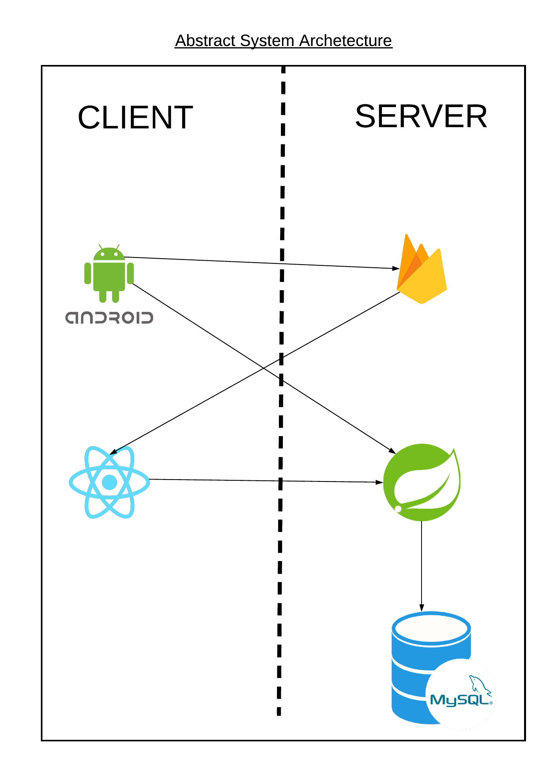

## System Architecture in Detail

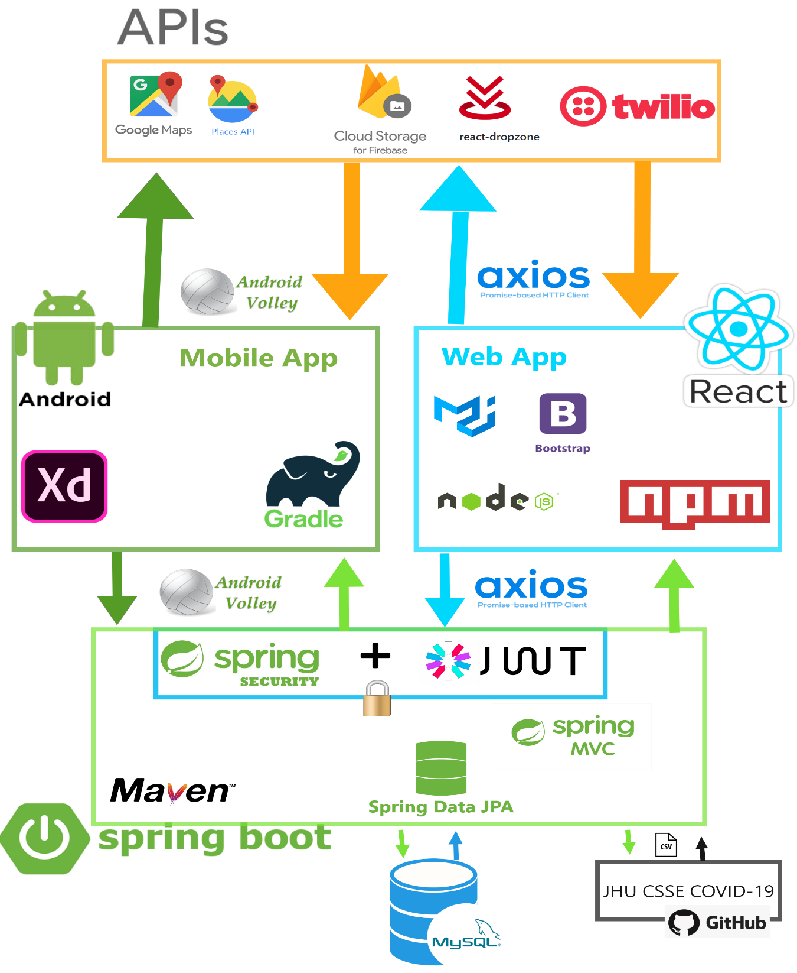

## Architecture Explained

The main platform is Spring boot. The spring boot application has multiple layers using (Spring MVC). The layers include

Controller layer

This is the layer that receives incoming api requests and handles them

Service layer

This is the layer that handles the more complex business logic and processing as well as access the DAOs.

Data Access Layer

This layer is used for retrieving data from the database with the help with the help of Spring Data JPA which is built on the JPA provider Hibernate

For storage.

My main storage is a mysql database. Which is a relational database management system.

Firebase storage is used for storing prescription images to improve database performance and image quality.

Front end

React Js for web application this is used by pharmacies and admin users

Android is used by patient users

## Design

**Server**

Spring boot by default comes with apache tomcat embedded when you have spring MVC dependency. So, this allowed quick deployment early on in the development life cycle. I had used Tomcat before in previously modules so was somewhat familiar with it

**Backend**

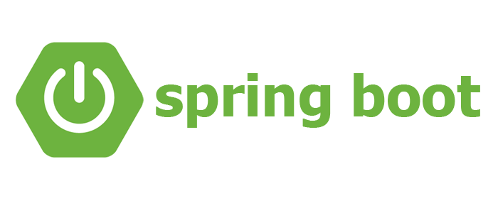

Spring boot is built on top of the spring framework. It provides functionality of spring but with less of the xml configuration. Spring boot allows annotation-based configuration. I found it difficult in the beginning to understand the structure, but eventually found it easier for receiving, processing and retrieving data.

**Front End**

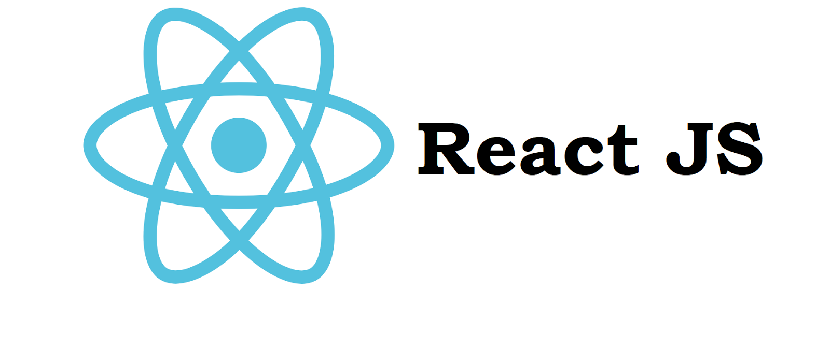

React is a JavaScript library for building user interfaces. It is maintained by Facebook. React can be used as a base in the development of single-page or mobile applications. The web app for pharmacies and admin use this. I found this to be the most difficult part of my project. Not being familiar with javascript language jumping straight to using a library/framework was difficult. I believe I will continue to try developing with JavaScript in future to improve.

**Front End Android Studio**



Having experience developing java applications helped when creating an android application. Most people’s phones use android OS.

**Database**

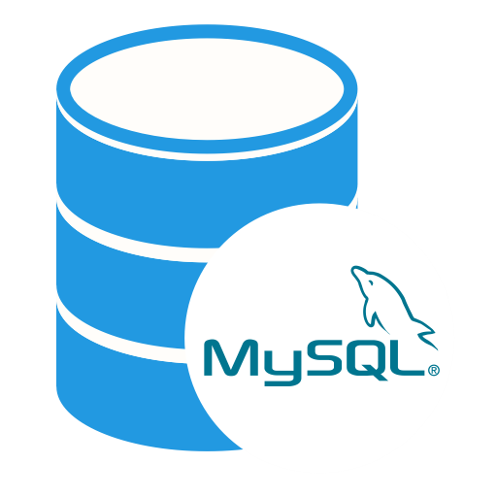

MySQL is an open-source relational database management system. In this course, it was the the DBMS system we used mostly. Before my relational database understanding was quite limited, I feel I have improved a lot with my understanding of how relational databases work from having chosen this database.

**Storage**



Firebase is a database service managed by google. Firebase offers wide range of easy to use products. One being firebase cloud storage which is exabyte scale object storage solution. I use this to store prescription images. I enjoyed using firebase and will definitely use it in future.

**Database Access**

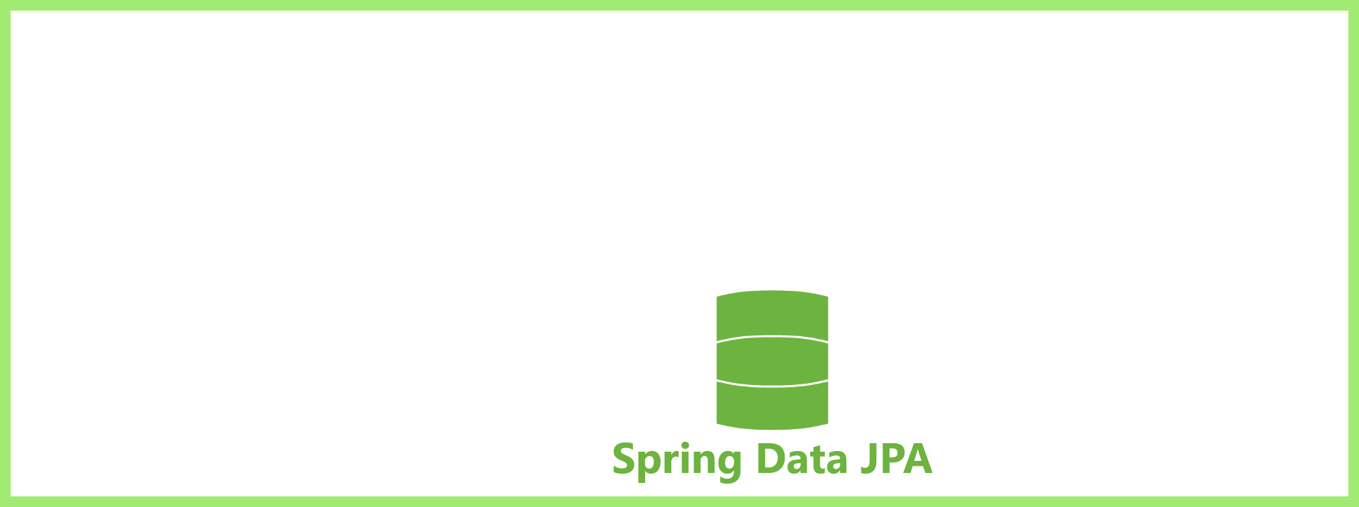

Spring Data JPA provides repository support for the Java Persistence API (JPA). It eases development of applications that need to access JPA data sources. It allowed me to make customizable named queries in the repositories.

**Object Relational Mapping**



Hibernate is an object relational mapping tool for java environments that maps domain model objects to relational database tables.

**Build automation**



Maven is a build automation tool used primarily for Java projects. I used this for adding dependencies to my spring application through the pom.xml. This year was my first year of using any build automation And I found it quite nice for visualizing dependencies

**Build automation**



Similar to maven, Gradle is a build automation tool that allows you easily add dependencies and is default for android studio. I believe the syntax for Gradle is easier to read and would scale nicer than maven in my opinion. I preferred Gradle as a build automation tool.

**Build automation**



Npm is a package manager for javascript and was used for the dependencies I added for my react project, like Axios and Chart.js, Count-up etc. Installing dependencies was relatively easy. E.g. ‘npm install …’

**HTTP Requests.**



To interact with my spring boot application from my React Js application I needed a Http client. Axios is a lightweight promise based Http client that allows asynchronous requests.

**HTTP Requests.**



To interact with my spring boot application from my Android application. I decide to go with Android’s Volley Library. I create a single instance of a request queue that was able to be used throughout my application. I was able to fetch JsonObjects, JsonArrays.

**Security**

 

For security I’m using Spring security with JWT. Spring security is in charge of authorization and authentication. To ensure apis cannot be accessed by wrong user. Authenticated using JPA and database details used.

JWT is JSON web token is an open, industry standard RFC 7519 method for representing claims securely between parties. After successful login a JWT token is generated and sent to user, which must be attached to every HTTP request, due to the statelessness of http request.

**UI**

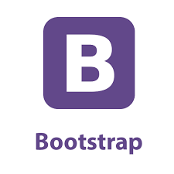

Bootstrap was the first CSS library I discovered. I integrated standard bootstrap library. I was unaware of react bootstrap. I found it easy enough in the beginning but quite limiting after a while and became somewhat of a hinderance. I ended up using a lot of custom styling css which I struggled with.

**UI**



I discovered material-UI later in the academic year and I preferred its Component based styling integrated. Going forward I will use a styling library like this.

**UI**



Adobe xd user experience design tool for web apps and mobile apps. It used for making prototypes for applications. I used it to help me visualize how I want the applications to look like. I mostly used it for Android. I was able to make custom buttons, Images etc that I wanted to use

**Project Management**



In terms of storing my progress in a distributed version control system, I chose Github for all 3 appplications. I was introduced to Github last year in dynamic programming module and I was familiar with the basics of version control. Over the duration of the academic year I became stronger at git commands and using github. I believe this will transfer over to help me in future when working on a team.

# Data model

## Entity Relationship Diagram

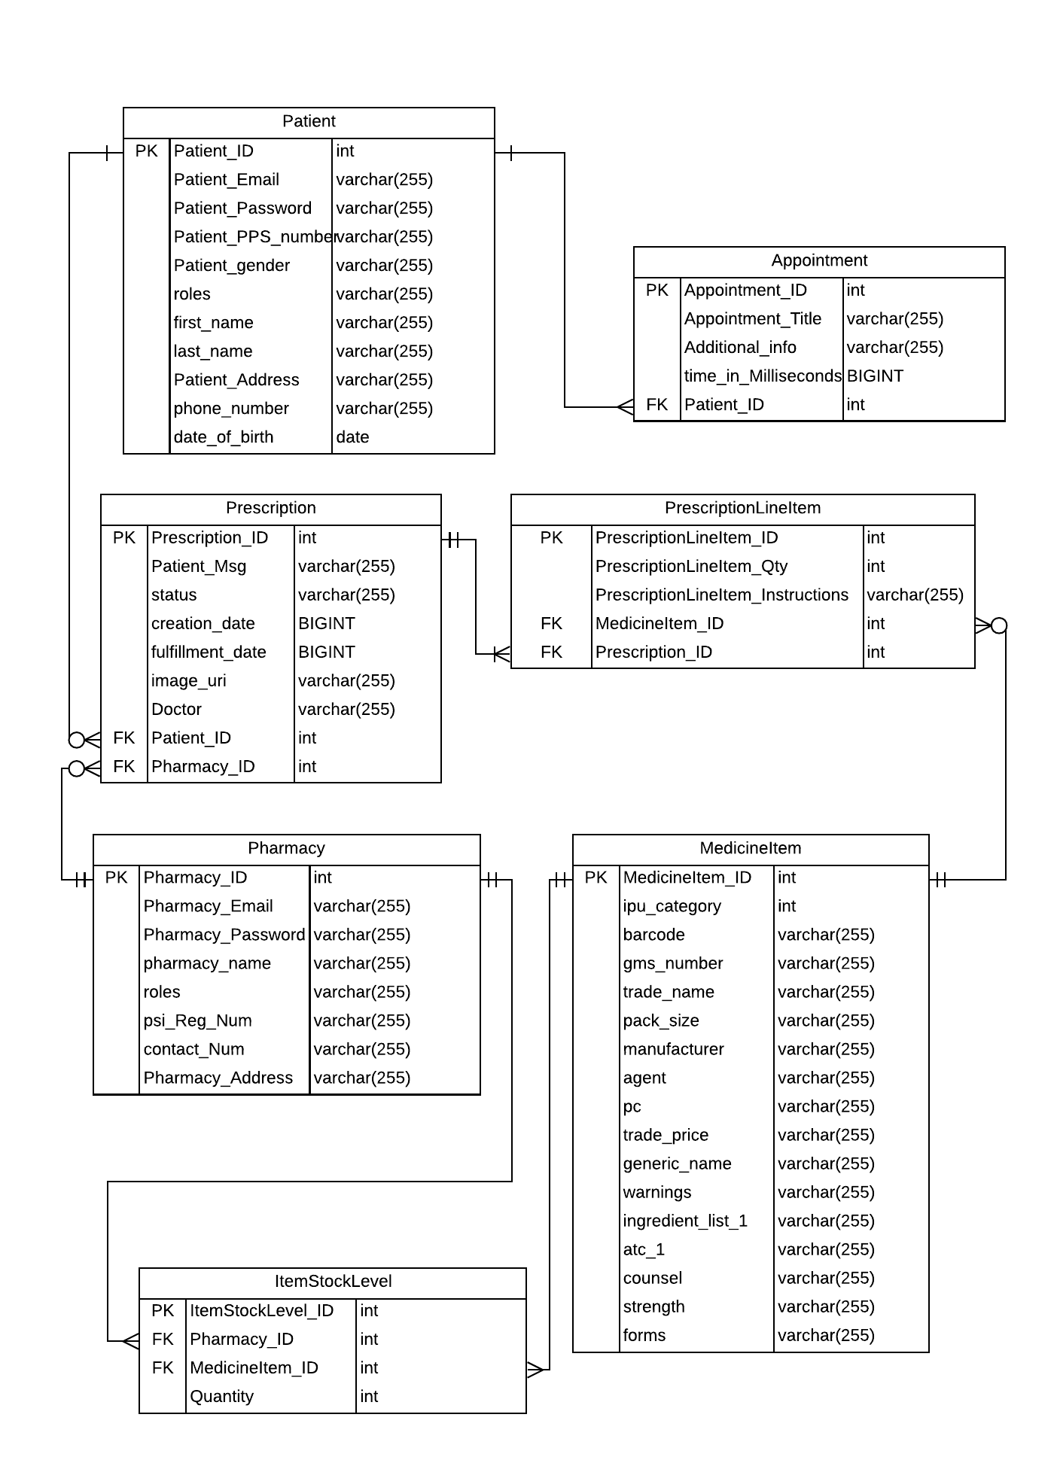

## Entity Medicine Data

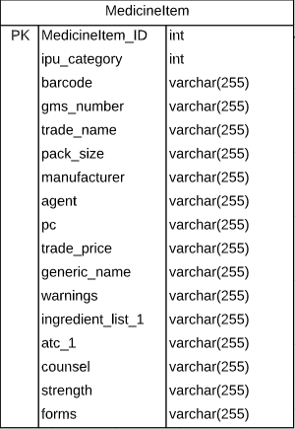

I was fortunate enough to be granted access to sample product file from the IPU which I used to help design my medicine entity

## IPU product file headings

Provided and maintained by the Irish Pharmacy Union (IPU)

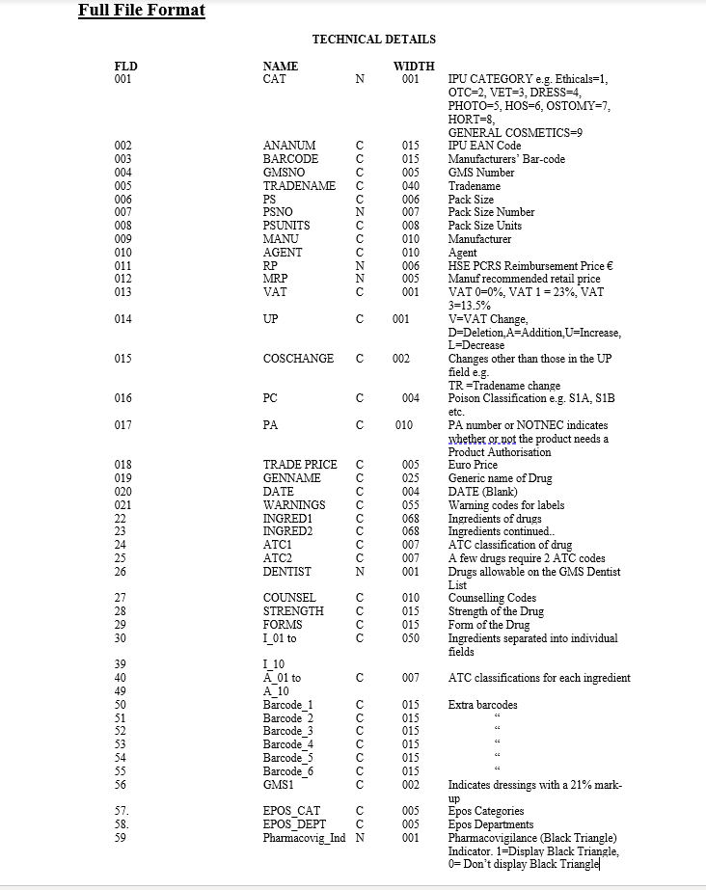

# Implementation

## APIs

**Twilio**



Twilio is an api I implemented for notifying patients when prescriptions are updated to status cancelled or ready.

Twilio allows you programmatically make and receive text messages through an api. My application makes an api request when prescription status is updated to a certain status. Then it sends a text message to a given number.

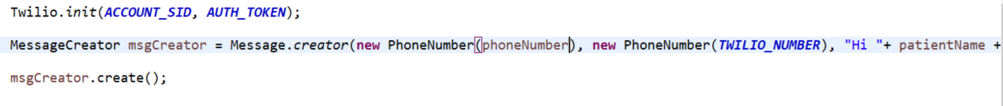

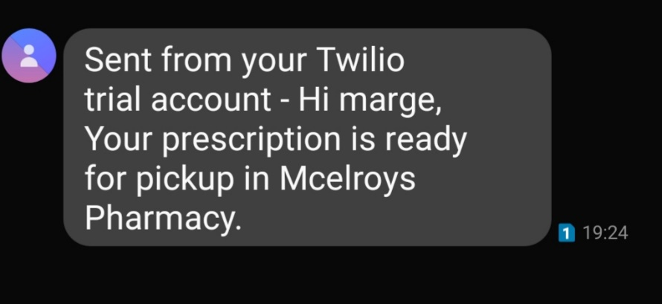

**Google Places API**

 

With google maps and google places api. Patient users can view pharmacies in the radius of where they are located.

This is useful if you are in an unfamiliar location and do not know where local pharmacies are. Or want to ensure you go to a pharmacy within 2km

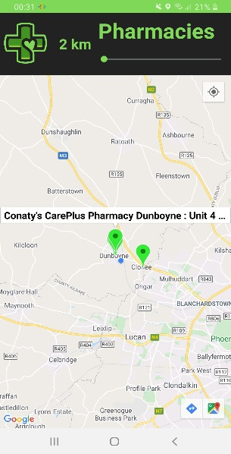 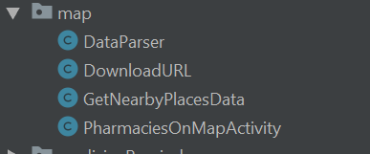

## Prescription

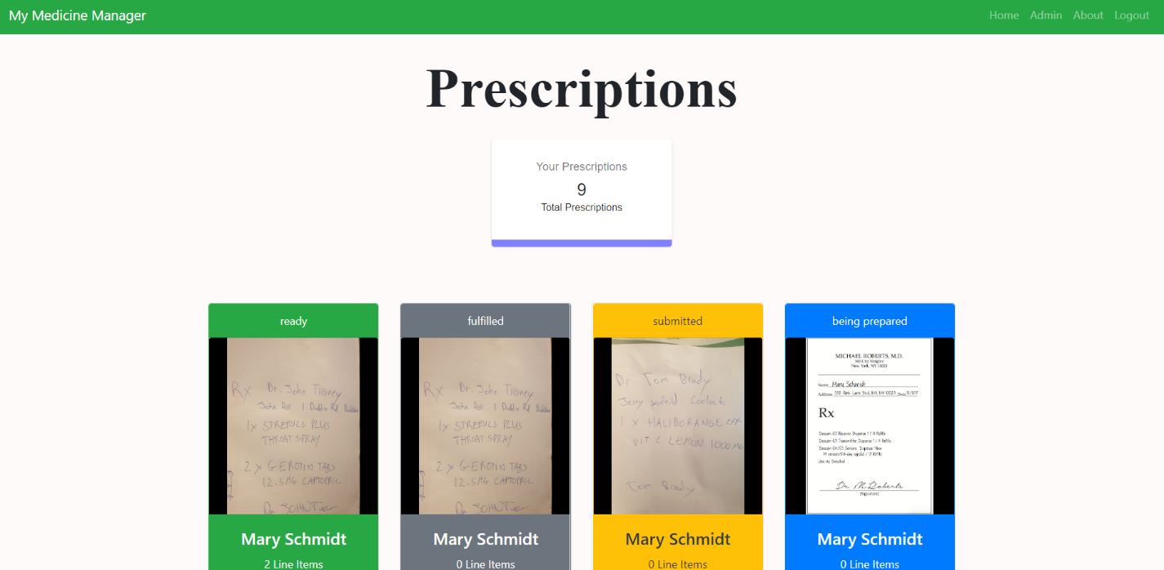

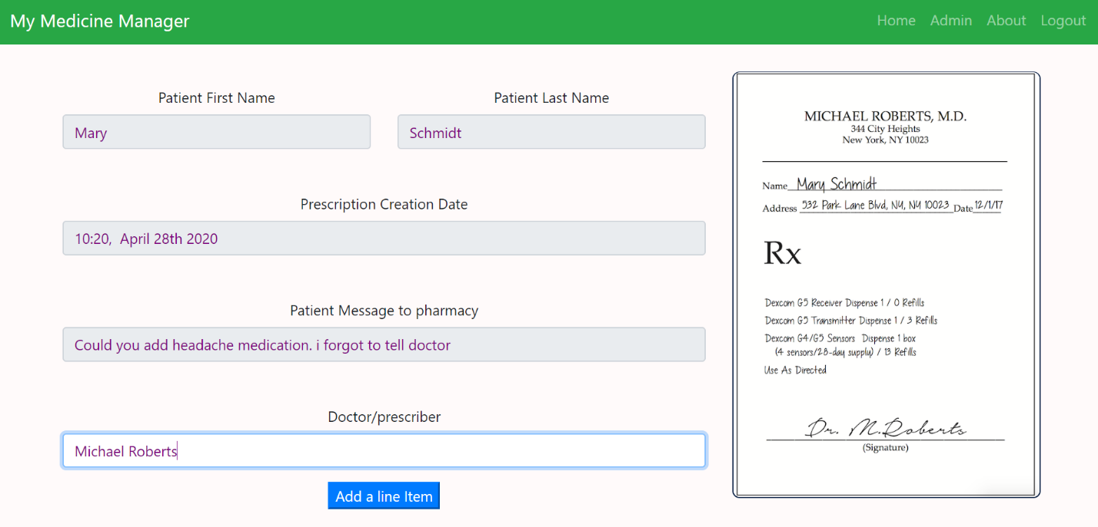

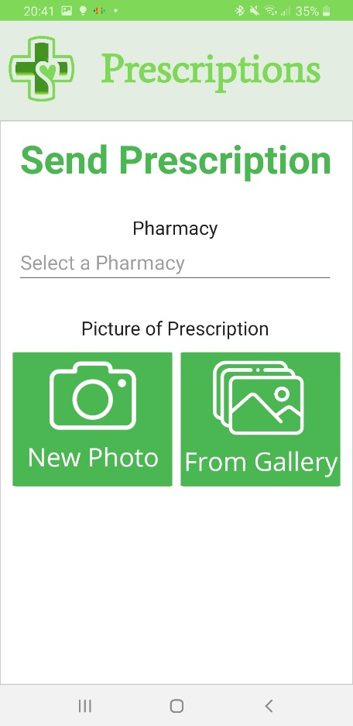 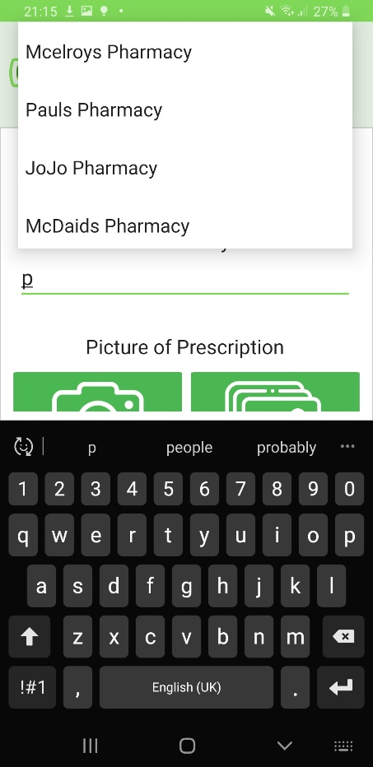

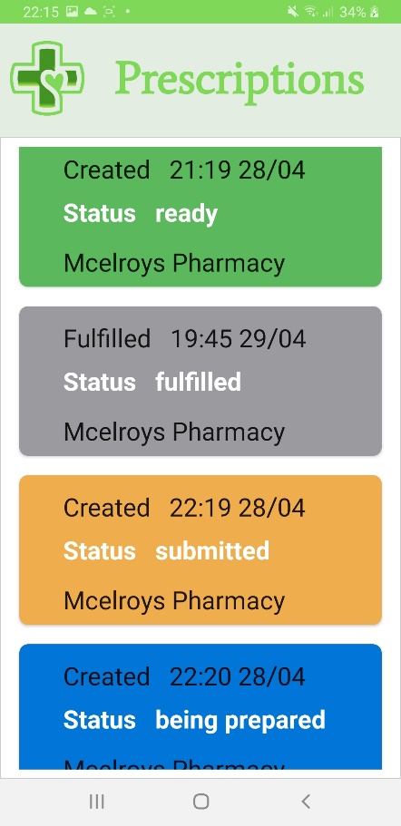

## Patient

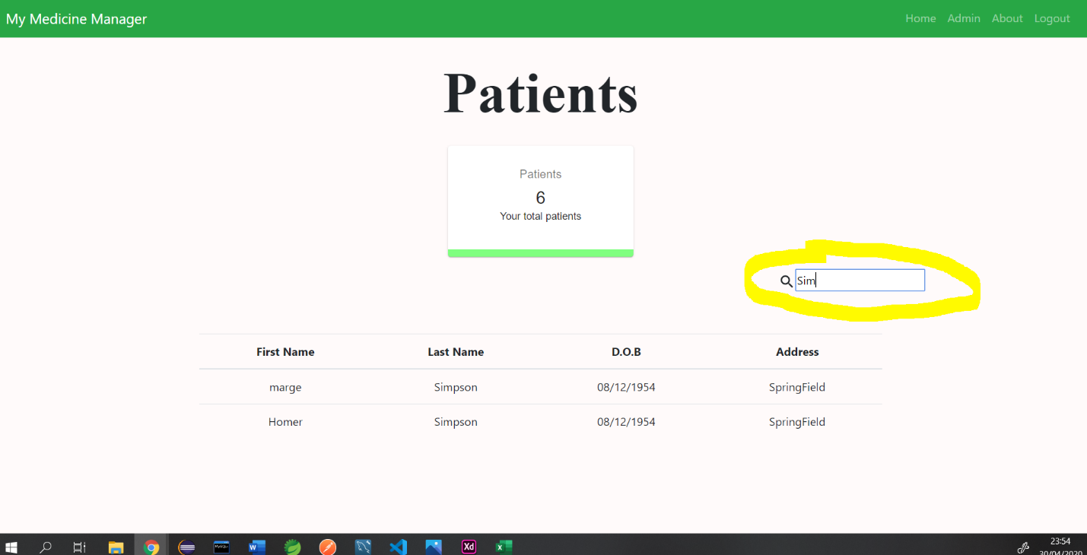

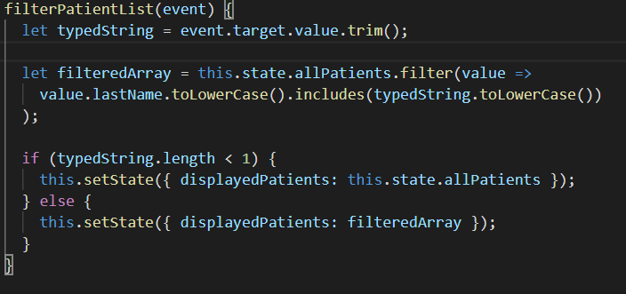

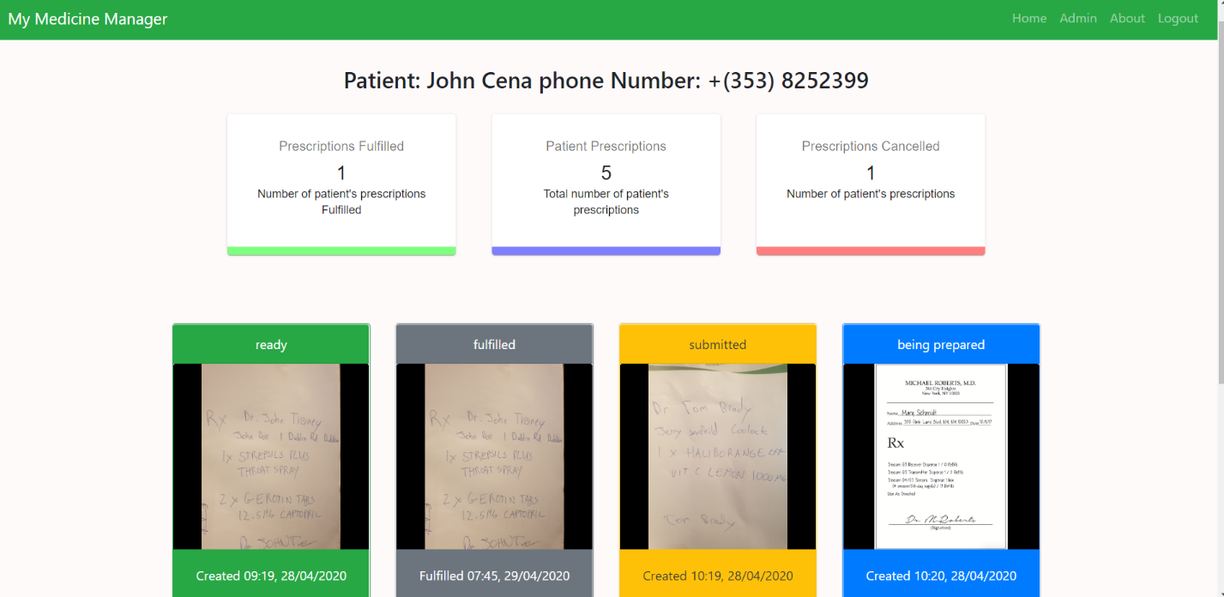

Patients give access permission to pharmacy if they send a prescription to that pharmacy.

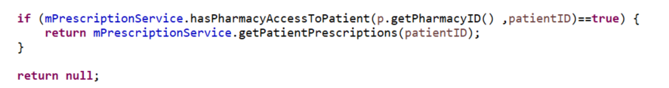

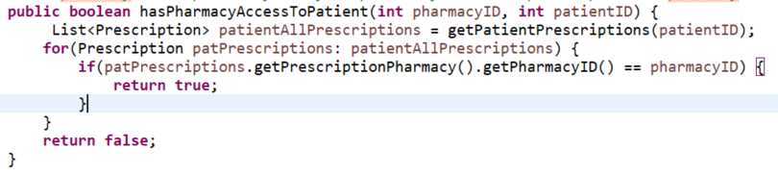

## Patient Appointments

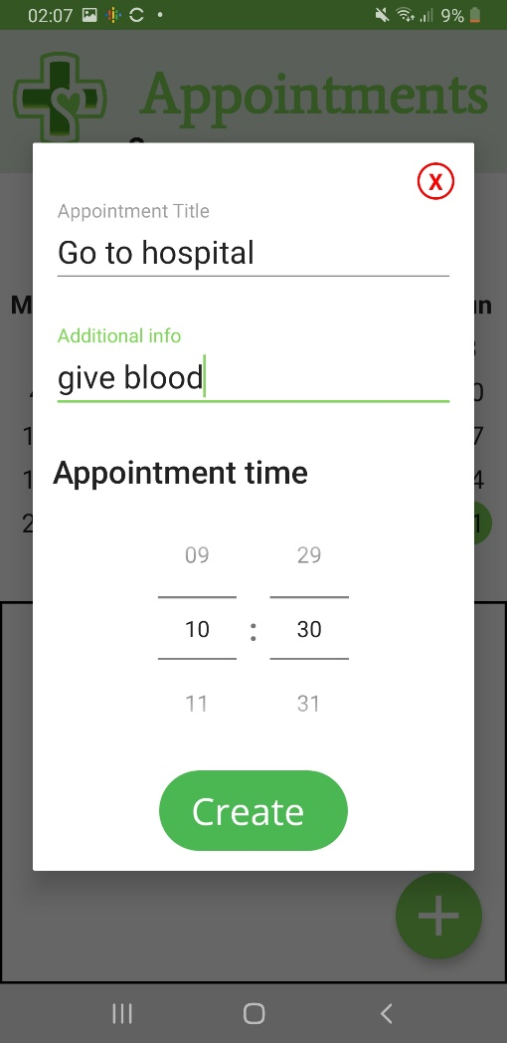 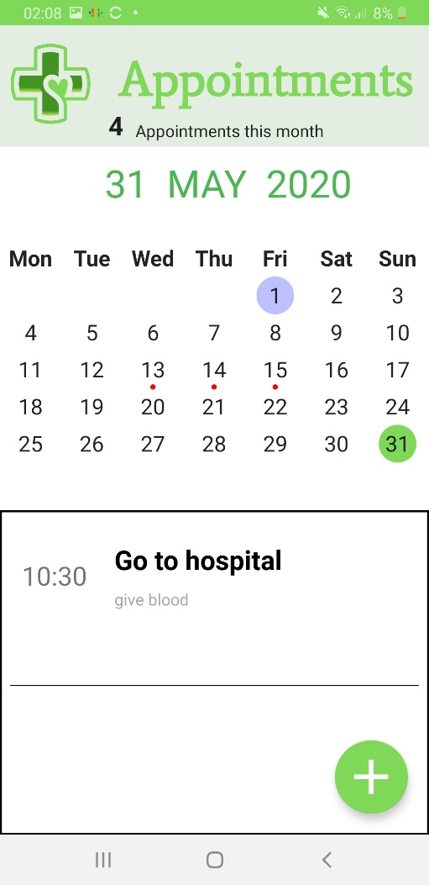

Patients can create appointments and view previous appointments to better gauge their health status trends. More appointments these past few months may make patient take corrective action.

## Medicine

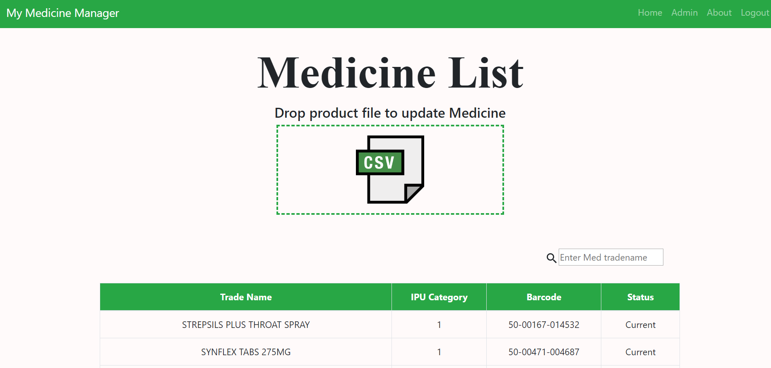

The Medicine list is updated and initialized by an admin user who populates the medicine list with a csv product file. If medicine exists on previous medicine list but not on updated one. Its status becomes end of life. This avoids medicine deletion which would lead to prescription history problems.

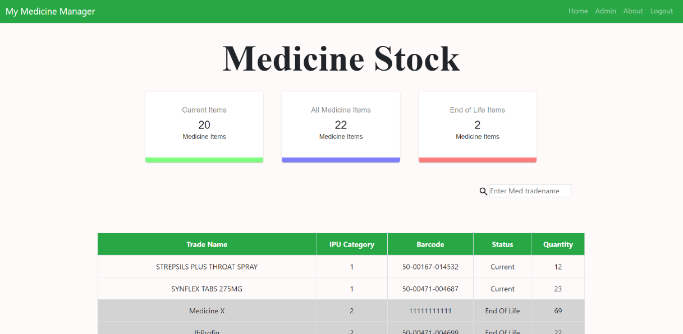

**Sample Product file**

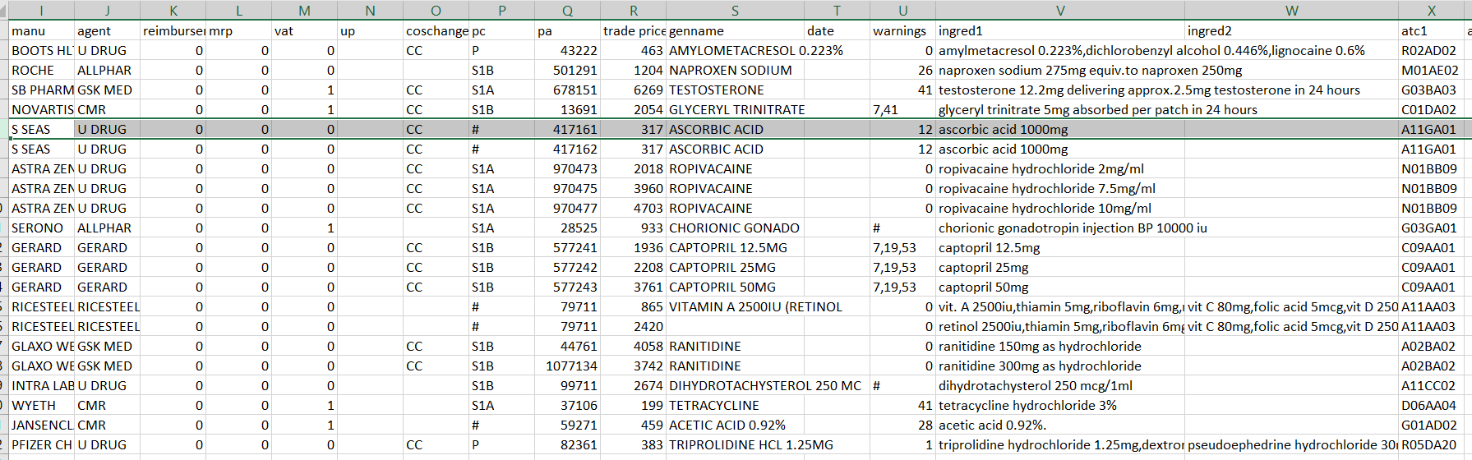

**React-DropZone**

HTML5-compliant drag’n’drop zone for files. PrescriptionService updates.

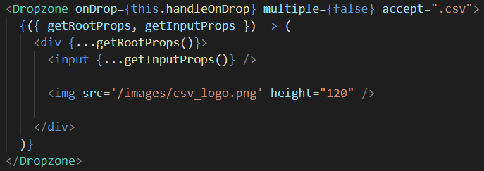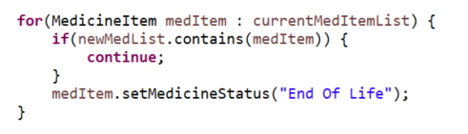

## Covid-19

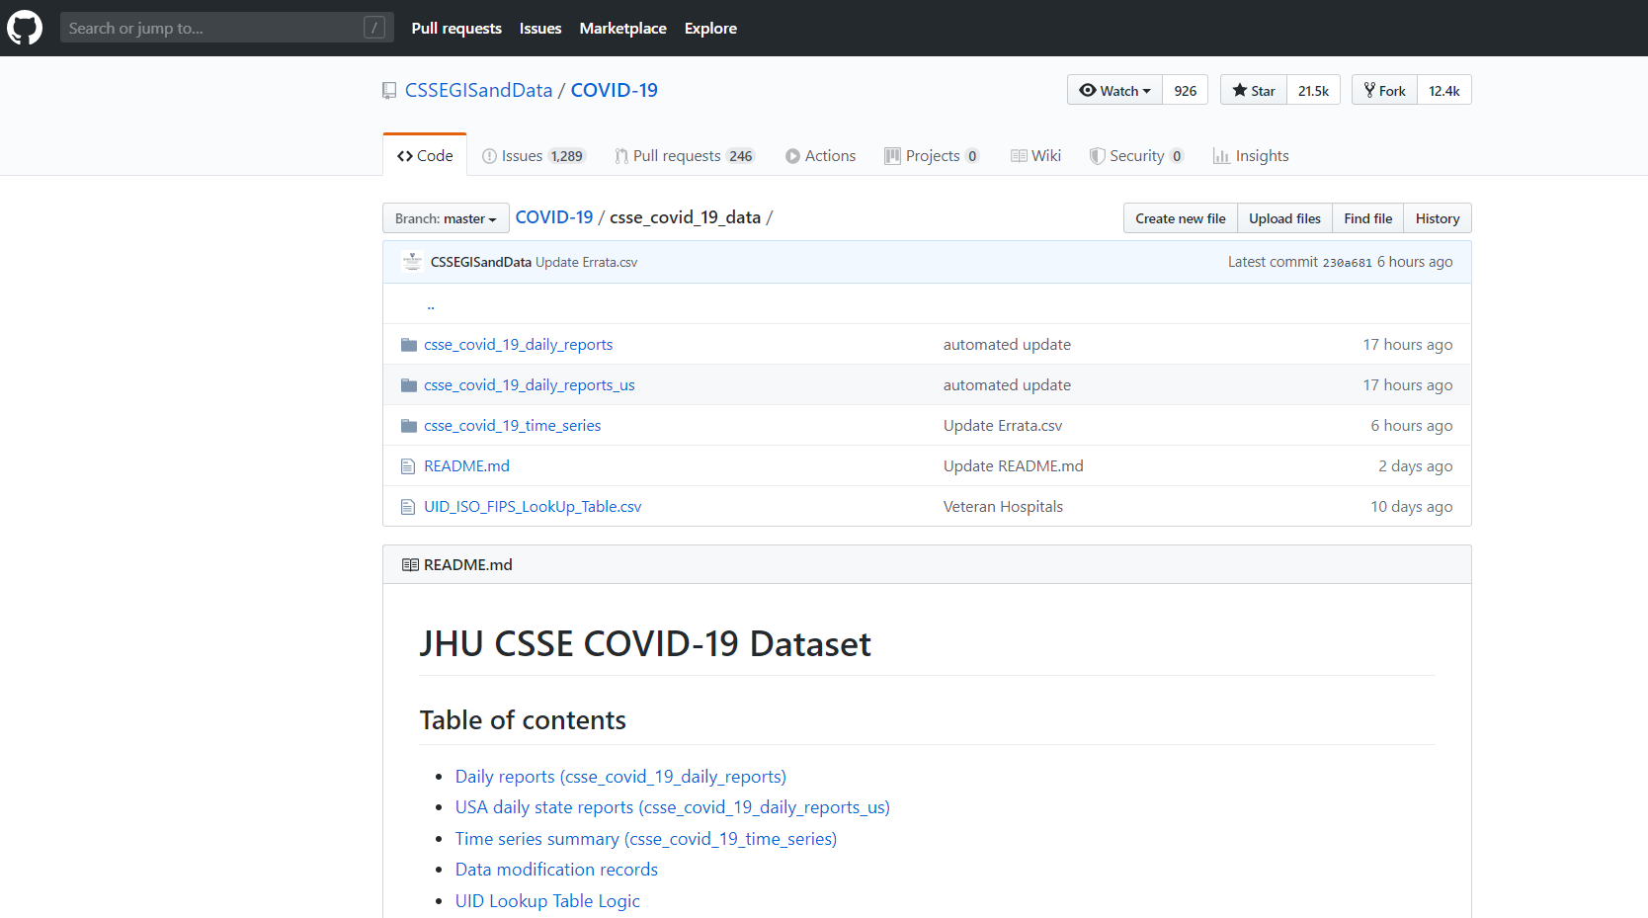

There are 3 csv files which I extract daily Covid-19 data from. A data source for location confirmed, location deaths and location recoveries. I add up all locations for each country. And display this. I add up all these to calculate global totals

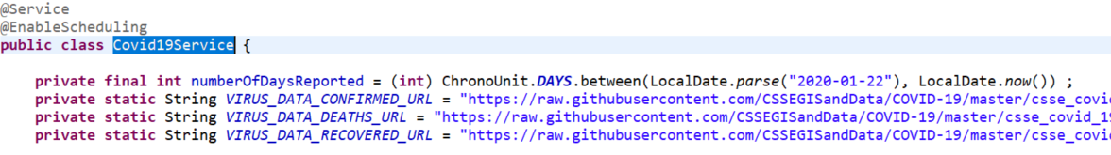

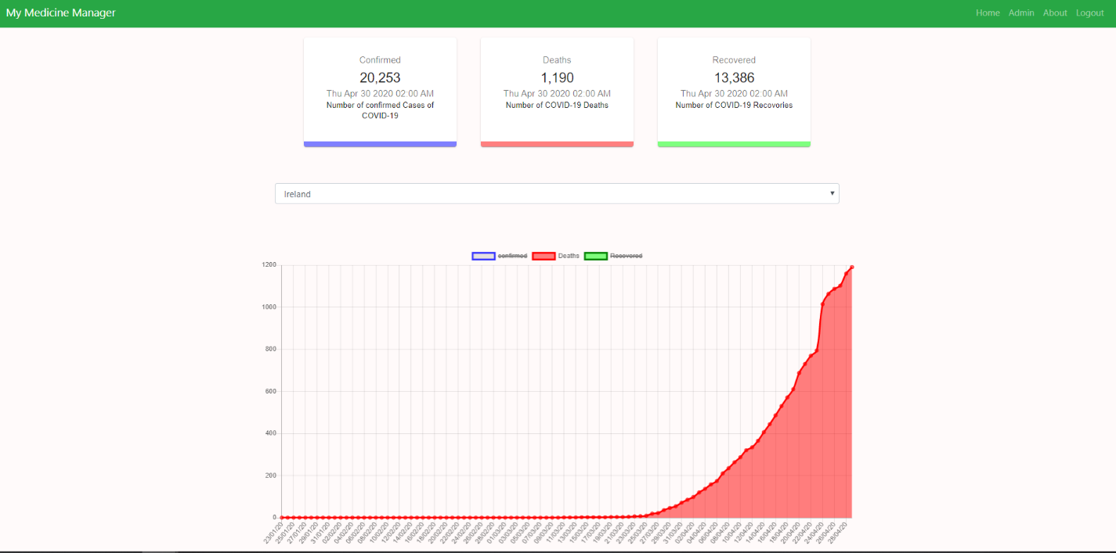

React-chart-js is utilized for this graph. React-count up is utilized for showing the numbers.

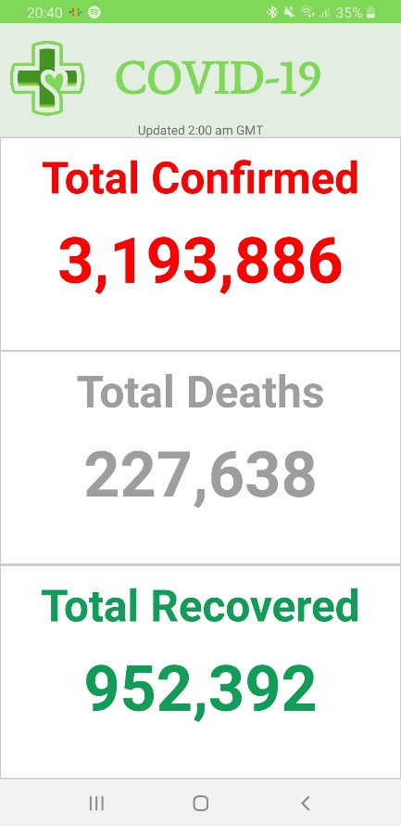 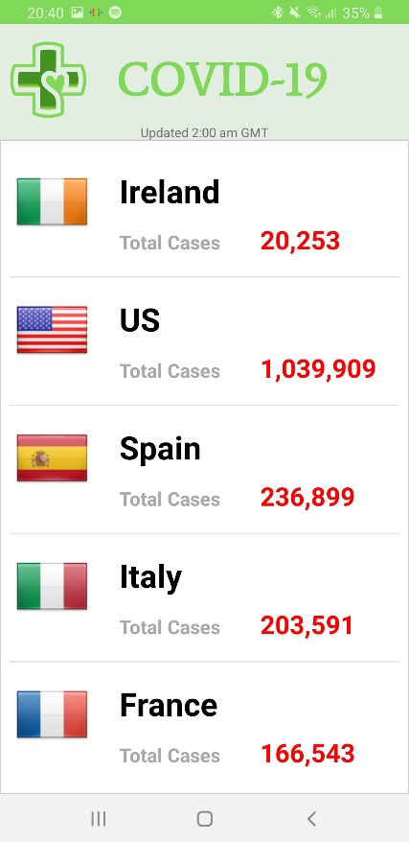 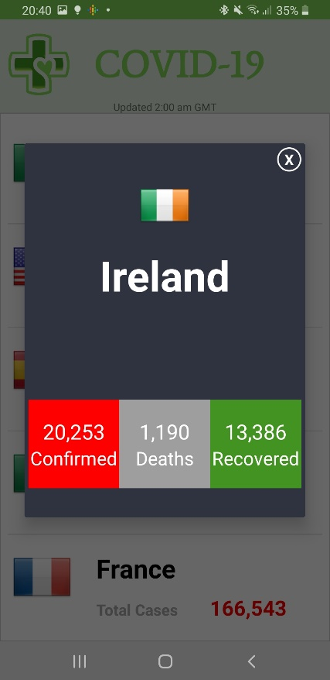

# Test Cases

|  |  |  |  |
| --- | --- | --- | --- |
| Name | Description | Expected Result | Result |
| Add medicine List | Admin user can post a csv list of product file which creates initial medicine list | Medicine entities created and existing pharmacies have access to these medicines | PASS |
| Find all medicine | Pharmacy users can see list of available medicines | Pharmacy can view list of medicine items plus the medicine status(Current or End of Life) | PASS |
| Update medicine Stock level | Pharmacies can update their own stock level | Pharmacy stock level adjust with entered values | PASS |
| View specific medicine details | Pharmacies can view details of a medicine | Pharmacy sees the details of medicine. | PASS |
| Search medicine by tradename | Pharmacy user can search medicine stock list by name | Filters list by trade name narrows down search of possible extensive list | PASS |
| View patient list | Pharmacy can see list of patients | Show patients that have prescriptions with that pharmacy | PASS |
| View Patient Prescricptions | Pharmacy can view all of their patients’ prescriptions. Even prescriptions assigned to other pharmacies | Pharmacy can see all their patient’s prescriptions to ensure correct medical practice | PASS |
| Update your prescription only | Pharmacies can only update their own assigned prescriptions | Pharmacy can view other pharmacy prescription for given shared patient x. but can only make changes to their own prescription | PASS |
| Patient gets text when prescription is cancelled or ready for pickup | Patient should have clear view of their prescription’s status | Patient gets text from twilio number saying prescription is ready or cancelled | PASS |
| Patient add appointments | Patient should be able to add appointments | Patients can create appoint events that are persisted and show on calendar view | PASS |
| Patient can send prescription | Patient can select given pharmacy and take picture of their prescription and send to pharmacy | Pharmacy receives this new prescription in list and new patient to patients | PASS |
| Patient sees up to date status of their prescriptions | Patient can see the current status of all their prescriptions | Show up to date prescriptions and their corresponding status | PASS |
| Patient update nearby pharmacy radius | Patients can use a slider to extend or narrow the nearby pharmacies on map | Show pharmacies in given radius 0-100km | PASS |

# GDPR

* Regulation in EU law on data protection and privacy for all citizens of European Union.
* Data protection regulations ensure that an individual’s right to privacy is respected.
* GDPR 7 key principles.
  + Lawfulness
  + Purpose limitation
  + Data minimisation
  + Accuracy
  + Storage limitation
  + Integrity and confidentiality(security).
  + Accountability.

## IPU Data protection GUIDE FOR Community Pharmacy

Regulation in EU law on data protection and privacy for all

* Pharmacies should ensure any information held on customers/patients is secure.
* Pharmacies should not disclose this information to third parties without person’s consent or unless there is a clear legal basis for such disclosure.

## GDPR Definitions

* “Personal Data” – any information relating to an identifiable person. Who can be identified from the data.
* “Data Concerning Health” – personal data related to physical or mental health of a person. Including patient medication record (PMR). Should be processed for health related purposes only e.g prescription details, medicines dispensed.
* “Data Controller” - Legal person or company who determines purpose and means of processing of personal data. E.g. Pharmacy
* “Data Processor” – Company who processes personal data on behalf of data controller. E.g. MyMedicineManager.
* “Processing” – Any operation performed on personal data. (Collection, recording, storage). Core activities carried out by Data Processor.
* “Consent” – Freely given permission of the data subject to the processing of personal data. In pharmacy context, consent can be taken as given where a patient supplies a prescription to a pharmacist to be dispensed.

## GDPR Types of Data

* Automated Data – Mainly covers information held on computers. Information to be transferred to an automated system. Automated data should be encrypted
* Manual data- paper records that are sufficiently structured with personal data. Manual data should be kept in a secure place.
* Pseudonymised data-
* Data exempt from regulations- Regulations to not apply to anonymised information. The regulations do not apply to the personal data of the deceased.

## Access to Personal Data by data Subject

* Patients have right, under regulation to make request to pharmacy to obtain a copy of any personal data
* Pharmacy must take Reasonable steps to ensure person requesting data is the data subject.
* In Most cases pharmacies must provide a copy of information. (Within 1 month of request)
* Data requested should be provided ideally in writing, where appropriate, electronically.

## Destruction of records

* Expected that records be maintained beyond minimum specified period. For patient safety.
* The Medicinal Products Regulations and The Misuse of Drugs Regulations require that prescriptions be kept for a period of 2 years. (minimum requirement)

# Conclusion

I am happy with the skills I have learned from this experience including

* Better understanding of relational databases.
* Foundation for developing front end apps with javascript
* Better understanding of how rest apis are used.

However, I feel like the project stack was a bit too extensive for my skill level and if I were to go back, I would reduce the scale of the application and increase the features.

Overall, this has been a positive experience, giving me a better insight into the development of both mobile and web applications.